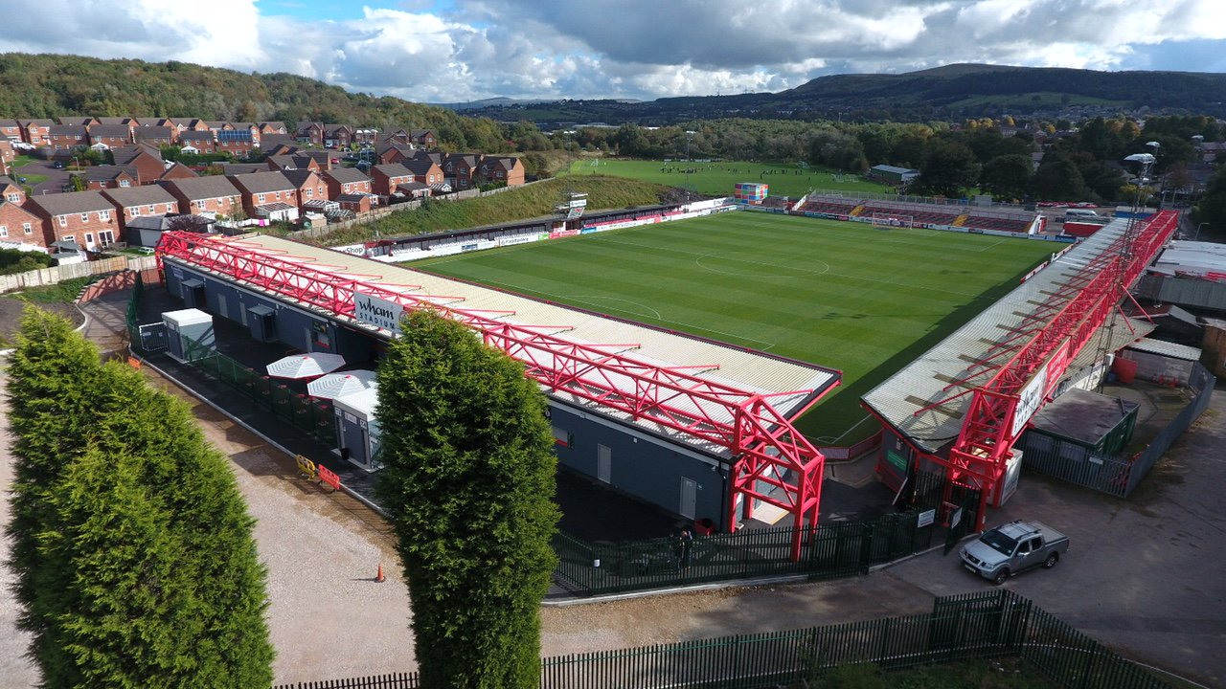
An Away Fans’ Guide
2018/19
The Wham Stadium

Accrington Stanley FC
Livingstone Road, Accrington, Lancashire. BB5 5BX
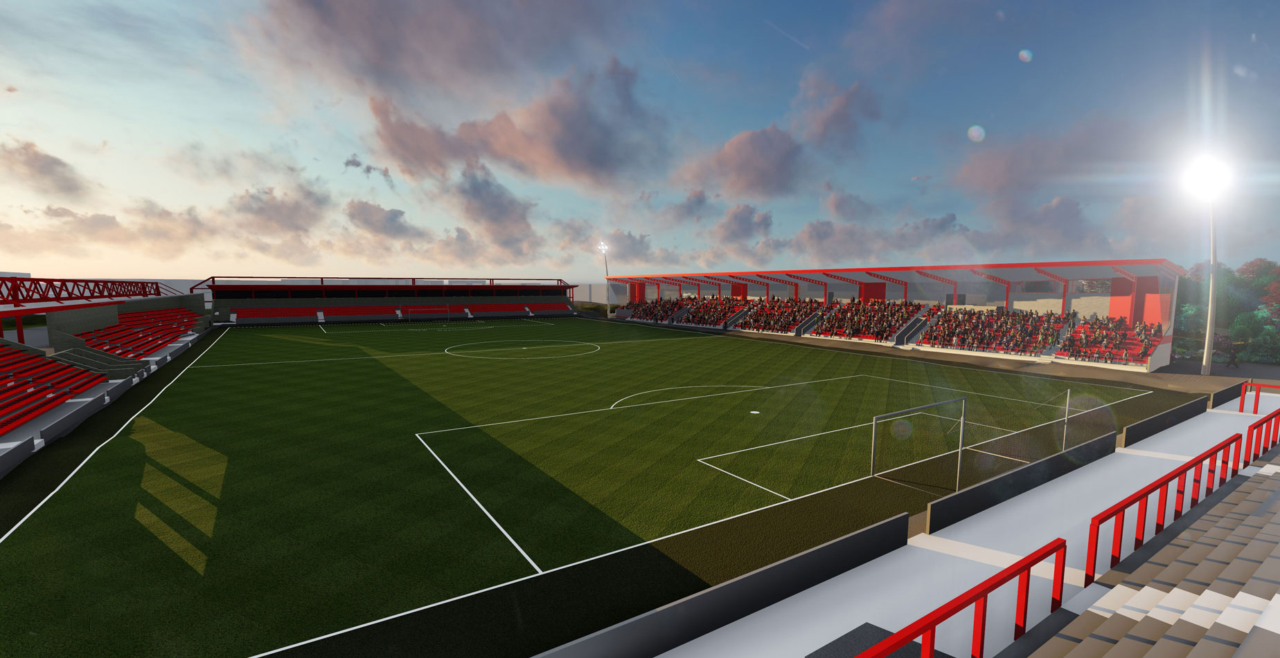
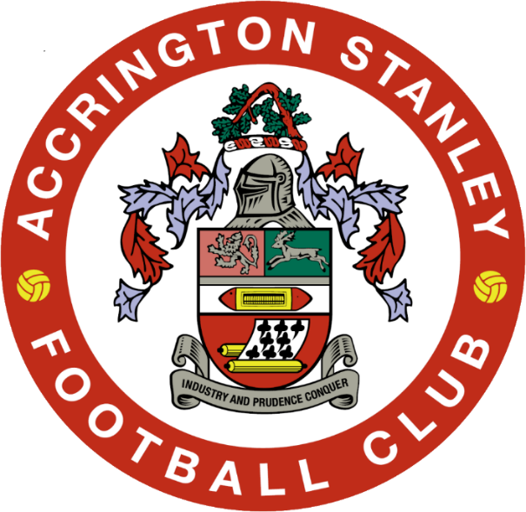
The Wham Stadium
Opened in 1970, it is situated in a residential area between Accrington Town Centre and Clayton-Le-Moors.

The stadium has a reduced capacity whilst a new all seater stand is constructed along the Whinney Hill side of the ground.
Away fans are located in the Coppice Terrace, an uncovered terrace with excellent views behind the goal and a limited number of seats in Block A of the main stand until the new stand is completed.
Please note that cash is not accepted at the turnstiles and entrance to the Wham Stadium is by ticket only.
Matchday Tickets are available from your club. Any unsold tickets are available on the day from 1:15pm (or 6:15pm before evening matches) from the Away Ticket Office situated in the blue cabin close to the away turnstiles.

Match

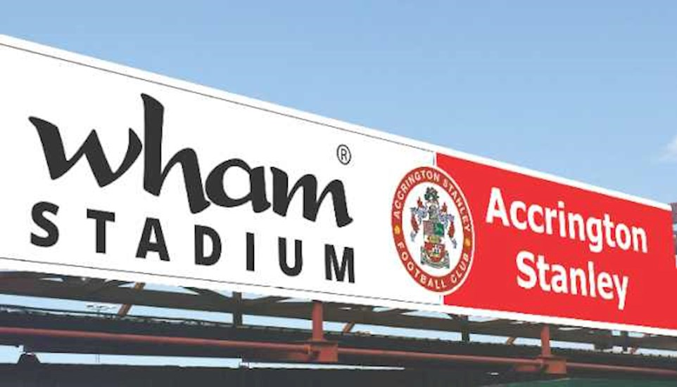
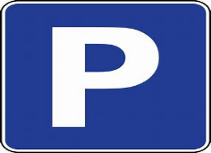 Parking and Public Transport
Parking at the stadium is £5 but is extremely limited. Places can be booked by ringing the club on 01254 356950 at least 24 hours before kick-off. Entrance to the car park is prohibited after 2:15pm or 7pm at evening matches.
Similarly, disabled parking can be booked on a first come first served basis.
There is plenty of parking in the streets surrounding the stadium. Presently there is no resident only parking, so please park responsibly.

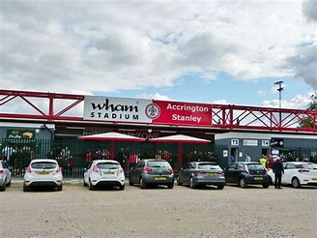
By train- The nearest station is Accrington, a 20 minute walk uphill to the stadium. Taxis are available outside the station. Accrington is situated on the Blackpool- Preston – Leeds line and there are also direct trains to Manchester Victoria.

By bus from Accrington town centre:
The nearest bus stop is opposite the Crown Pub and is reached by the Hyndburn Circular Bus. This runs every 15 mins from the main bus station in Accrington town centre.
Driving to the Wham Stadium
SAT NAV: BB5 5BX
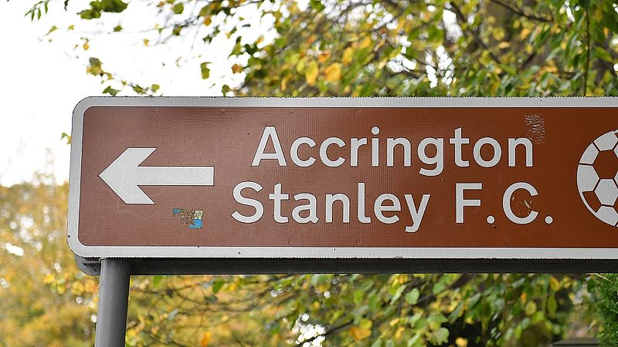
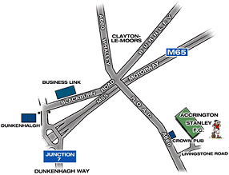

From the M65 -Leave the M65 at Junction 7, taking the Clitheroe turn off the roundabout. Turn right at the first set of traffic lights following the A678. Follow the road to the next set of traffic lights. Turn right again towards Accrington on the A680. Carry straight on at the next set of lights with the Greyhound pub on your right. Take the first left after the Crown pub into Livingstone Road.

From the M66-At the end of the M66 follow the A56 until you come to the Rising Bridge roundabout.
Take the first turning, the A680 towards Accrington for around 3 miles. Follow the ring road around the town centre. Opposite the Castle pub, turn right to rejoin the A680 following signs for Clitheroe and Clayton-Le-Moors. Drive up the hill under the railway bridge, through one set of lights and over a mini-roundabout. Livingstone Road is the next turning on the right.

Accrington Stanley FC Matchday Pricing 2018/19
Prices for admission to all league games are as follows:
Seating or Standing

Adults: £20.00
Concessions: £15.00*
12-17: £10.00
Under 12s: £5.00**

* for all concessionary tickets, valid ID must be shown at the ticket office (concessions are 65 and over or Students).
** All under 12s must be accompanied by an adult.

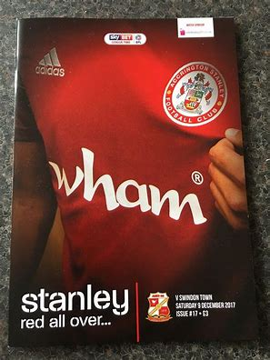

Programmes are on sale outside the stadium for £3

Disabled Supporters
Disabled supporters are admitted at the age appropriate price.
Where assistance is required in the form of a personal assistant (PA), the PA is admitted free or charge. Proof of disability is required in order to qualify for the complementary PA ticket.
To qualify, a supporter must receive medium or higher level of Disability Living Allowance / PIPS and produce evidence of this when purchasing the ticket.A total of 6 wheelchair bays are available for away fans in the HML Recycling Jack stand (Block A)
All supporters requiring a wheelchair space must contact their club or Accrington Stanley in advance to reserve one of these six places.
Hospitality
Places to Stay
Mercure Dunkenhalgh Hotel, Clayton-le-Moors.
1.5 miles from stadium. Tel: 01254 426800
Quote ‘Accrington Stanley’ for a discount

Sparth House Hotel, Clayton-le-Moors
1.4 miles from stadium. Tel: 01254 872263
Travelodge, Blackburn, Junction 4 M65
7.9 miles from the stadium. Tel: 08719 846122
Holiday Inn Express, Burnley, Junction 10 M65
8.3 miles from the stadium. Tel: 01282 855955
Willows by Marston’s Inn, Blackburn Junction 5 M65
6.3 miles from the stadium. Tel: 01254 681550

Hospitality which includes match ticket, a home-cooked three course meal, complimentary team sheet and official matchday programme with a car parking space on the main car park is available for £55 including VAT.
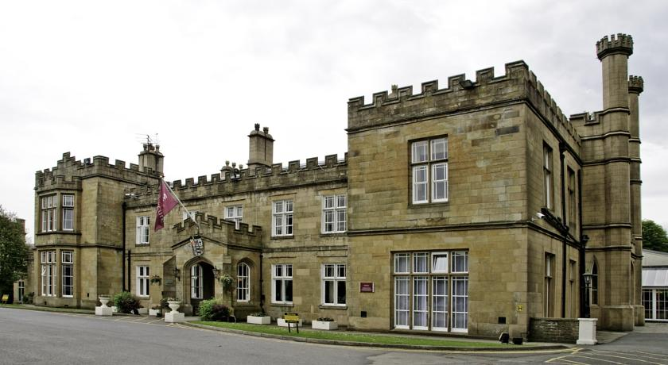
For more information or to book please contact the commercial team on 01254 356950 or email:
Between 12pm and 1:30pm away fans are welcome in our REDZ BAR. Entrance is by Match Ticket only.
When the turnstiles open at 1:30pm away supporters can get a drink inside the ground from the bottle bar behind the terracing.
Food is available outside and inside the ground.
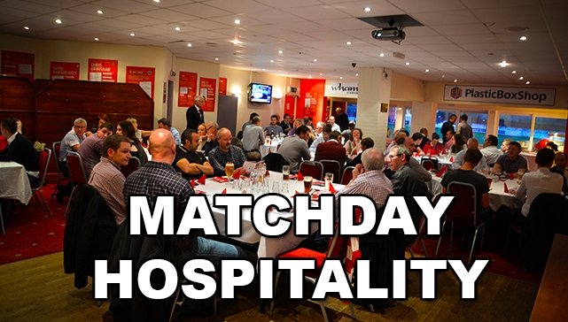
Food & Drink

